Phishing Tool Guide
Blair Davidson
2202504

Contents
1. How to use the tool 3
2. About the tool 4
2.1 What the tool does 4
2.2 How the scoring system works 5
2.3 Educational value side 5
3. References 6

How to use the tool
Step 1:
After running the code, you will be prompted to either enter in manually one of the email examples or can click and drag them in instead.

Step 2:
Once your email has been chosen either type END in all caps on a new line if copied and pasted was chosen or press enter after dragging the example into the terminal instead.

Step 3:
The tool will then provide detection information such as reasoning, suggestions and next appropriate steps to take if one of the chosen examples has been flagged.

Step 4:
After the tool is done checking the example you will be prompted to either end the program or test another example, if you continue testing then the tool will repeat from step one. If you choose to end program, then the tool will end.

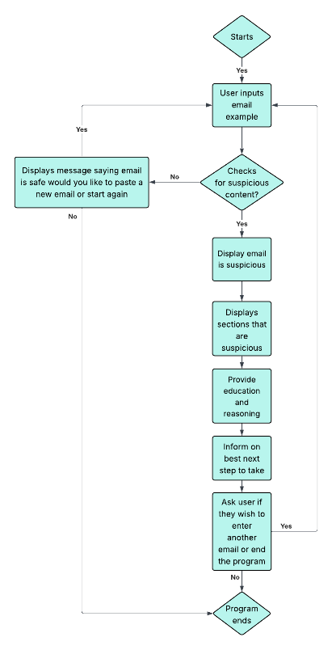

Figure 1-Tools workflow example

About the tool

2.1 What the tool does
The tool scans chosen email text and looks for phishing indicators
It achieves this by checking for the following:
- Suspicious language
Looks for wording attackers often use such as:
- urgency - act now within 24 hours
- threats - account suspended and legal action
- credential theft - verify your account and reset password
- payment baiting - invoice, refunds and transactions
- Dangerous Attachments
Flags any wording that suggests malware delivery such as:
- Attached invoices
- .Zip
- .doc
- Download the attachment

- Suspicious Links
The URL scanner checks for:
- URL shorteners like bit.ly or tinyurl
- Raw IP links
- @ in the URLs
- Long URLs
- Suspicious amount of subdomains

- Generic messaging
Catches generic greetings and messages such as:
- Dear customer
- Dear user

2.2 How the scoring system works
Each finding that has been classed as suspicious by the tool has a weight score to them such as:
- credential theft wording = +16
- IP address link = +18
- URL shortener = +15
- urgency = +10

The tool then uses the weighted scores to determine the threat level of the input example as seen below:
- 0–5 - Appears Safe
- 6–15- Low Risk
- 16–30 - Medium Risk
- 31–60 - High Risk
- 61+ - Phishing / Very High Risk

2.3 Educational value side
The tool not only detects suspicious content and classifies the phishing risk but also educates the user by explaining why each indicator is suspicious and provides suggestions for next safe action to take. This method improves the users’ awareness and supports the tools phishing awareness training.

References
Basnet, R.B., Sung, A.H. and Liu, Q., 2011. ‘Rule-based phishing attack detection’. In: Proceedings of the International Conference on Security and Management (SAM 2011). Las Vegas, NV: CSREA Press, pp.1-7. Available at: https://www.researchgate.net/publication/265919217_Rule-Based_Phishing_Attack_Detection, (Accessed on the 23rd of January 2026).

Wood, T., Basto-Fernandes, V., Boiten, E. and Yevseyeva, I., 2022. Systematic literature review: anti-phishing defences and their application to before-the-click phishing email detection. arXiv. Available at: https://www.researchgate.net/publication/360232970_Systematic_Literature_Review_Anti-Phishing_Defences_and_Their_Application_to_Before-the-click_Phishing_Email_Detection, (Accessed on the 26th of January 2026).

Naidoo, R., 2016. ‘Analysing urgency and trust cues exploited in phishing scam designs’, South African Computer Journal, 28(1), pp.1-14. Available at: https://www.researchgate.net/publication/281843032_Analysing_urgency_and_trust_cues_exploited_in_phishing_scam_designs, (Accessed on the 30th of January 2026).

Butavicius, M., Parsons, K., Pattinson, M. and McCormac, A., 2016. ‘Breaching the human firewall: social engineering in phishing and spear-phishing emails’. In: Australasian Conference on Information Systems (ACIS 2016), pp.1-11. Available at: https://www.researchgate.net/publication/303812216_Breaching_the_Human_Firewall_Social_engineering_in_Phishing_and_Spear-Phishing_Emails, (Accessed on the 30th of January 2026).

Shahriar, S., Mukherjee, A. and Gnawali, O., 2022. ‘Improving phishing detection via psychological trait scoring’, Journal of Cybersecurity and Privacy, 2(3), pp.455-470. Available at: https://arxiv.org/abs/2208.06792, (Accessed on the 15th of February 2026).

Yasin, A. and Abuhasan, A., 2016. ‘An intelligent classification model for phishing email detection’, International Journal of Computer Applications, 148(14), pp.15-22. Available at: https://www.researchgate.net/publication/305919533_An_Intelligent_Classification_Model_for_Phishing_Email_Detection, (Accessed on the 21st of February 2026).

Parsons, K., McCormac, A., Butavicius, M., Pattinson, M. and Jerram, C., 2016. ‘Do users focus on the correct cues to differentiate between phishing and genuine emails?’. In: Australasian Conference on Information Systems (ACIS 2016), pp.1-10. Available at: https://www.researchgate.net/publication/303283612_Do_Users_Focus_on_the_Correct_Cues_to_Differentiate_Between_Phishing_and_Genuine_Emails, (Accessed on the 27th of February 2026).

Python Software Foundation, 2026. Regular expression operations. Available at: https://docs.python.org/3/library/re.html, (Accessed on the 29th of January 2026).

Real Python, 2026. Python standard library, Data classes. Available at: https://realpython.com/ref/stdlib/dataclasses/, (Accessed on the 15th of February 2026).

Python Software Foundation, 2026. dataclasses - Data Classes. Available at: https://docs.python.org/3/library/dataclasses.html, (Accessed on the 16th of February 2026).

Python Software Foundation, 2026. urllib.parse - Parse URLs into components. Available at: https://docs.python.org/3/library/urllib.parse.html, (Accessed on the 28th of February 2026).

TutorialsPoint, 2026. urllib.parse - Parse URLs into components in Python. Available at: https://www.tutorialspoint.com/article/urllib-parse-parse-urls-into-components-in-python, (Accessed on the 1st of March 2026).

Python Software Foundation, 2026. os.path - Common pathname manipulations. Available at: https://docs.python.org/3/library/os.path.html, (Accessed on the 5th of March 2026).

Real Python, 2026. Python standard library, os. Available at: https://realpython.com/ref/stdlib/os/, (Accessed on the 5th of March 2026).

Python Software Foundation, 2026. Built-in Functions. Available at: https://docs.python.org/3/library/functions.html, (Accessed on the 20th of March 2026).

Tufte, E.R., 2001. The visual display of quantitative information. 2nd edn. Cheshire, CT: Graphics Press. Available at: https://www.researchgate.net/publication/50371823_The_Visual_Display_of_Quantitative_Information_ER_Tufte, (Accessed on the 21st of March 2026).

Python Software Foundation, 2026. sys - System-specific parameters and functions. Available at: https://docs.python.org/3/library/sys.html, (Accessed on the 21st of March 2026).

Real Python, 2026. Python standard library, sys. Available at: https://realpython.com/ref/stdlib/sys/, (Accessed on the 22nd of March 2026).

